

Digital Logic Design Project Multisim (Digital StopWatch)
Name: Retaj Ali Ismael Ali
ID: 231005689
Name: Bassel Osama Ahmed Soliman
ID: 231005711
Supervised by: Eng. Sara Ashraf
- Project description
Overview: The project is a digital stopwatch circuit. It uses digital logic components to measure and display time in minutes and seconds. It uses switches for starting and stopping the time.
Its purpose: The circuit's purpose is to measure time using digital logic, using counters, decoders, Function generator, switches, and 7-segment displays.
Objectives: The objectives of this project are to implement a functional digital stopwatch that counts and displays time, using 7490N counters, 7447N decoders, and seven-segment displays. The stopwatch is to count minutes and seconds, and use switches to start/stop the counting process.
Problem seeks to solve: The project solves the problem of how digital components can be used to measure and display time. It addresses the challenge of building a digital stopwatch using multisim components.
Project’s relevance to digital systems and its practical applications: This project shows how basic digital parts can work together to make a digital stopwatch. It uses counters to count the time, decoders to help display the numbers, and displays to show the time.

- Project flow
Flowchart Description:
1-The process starts with the clock signal being enabled through the switches
2-The clock signal drives the first set of counters (U1 and U2). These counters count seconds.
3-When the seconds counter reaches 60, the counters reset and a carry signal is sent.
4-This carry signal causes a second set of counters (U9 and U13) to count minutes.
5-The outputs of both the seconds and minutes counters are sent to decoders.
6-The decoders (U3, U4, U8, and U12) convert the counter outputs.
7-The decoders send the converted signals to the 7-segment displays (U5, U6, U10, and U11) which show the time.
8-The stopwatch can be stopped by the clock signal using switches.
Describe the overall system flow, including the inputs, processing steps, and outputs:
System Flow:
Inputs:
Clock signal from XFG1.
Start/Stop signal from switches S1 and S2.
Processing Steps:
The 7490N counters (U1, U2) increment to count seconds.
The 7490N counters (U9, U13) increment to count minutes.
The 7447N decoders (U3, U4, U8, U12) convert the counter outputs.
Outputs:
The 7-segment displays (U5, U6, U10, and U11) show the minutes and seconds.

- Component Functionality
Function Generator (XFG1):
Role: The XFG1 component provides a clock signal for the circuit
Reason for Selection: The clock signal is needed as a timing source for the counters
Inputs: No direct input in the circuit diagram
Outputs: Clock signal output connected to the switches and counters
Contribution: The clock signal allows the counters to increment the time to be measured
----------------
Start/Stop Switches:
Role: The switches control the flow of the clock signal
Reason for Selection: To start and stop the stopwatch
Inputs: Manual interaction from the space bar
Outputs: Clock signal when enabled, no signal when disabled
Contribution: The switches allows the user to control the stopwatch
----------------
7490N Decade Counter (U1, U2, U9, U13):
Role: These ICs count the clock pulses
Reason for Selection: Used to create the counting functionality. They are decade counters, to count in base 10 numbers
Inputs: Clock pulses from the clock generator by switches for U1. Carry output from last counter for U2, U9 and U13
Outputs: BCD outputs sent to the decoders, and a carry out signal for the seven-segment-display
Contribution: The counters keep track of the time, with U1 and U2 counting seconds and U9 and U13 counting minutes
----------------
7447N BCD to Seven-Segment Decoder (U3, U4, U8, U12):
Role: These ICs decode BCD output from counters to stimulate the seven-segment displays
Reason for Selection: The decoders make it possible for the displays to show the correct numbers
Inputs: BCD output from the 7490N counters
Outputs: Signals to stimulate the seven segments of the displays
Contribution: The decoders convert the BCD information from the counters into signals that can be used by the seven-segment displays
----------------
Seven-Segment Displays (U5, U6, U10, U11):
Role: These display the time in digits
Reason for Selection: Used as a way to show the time
Inputs: Signals from the 7447N decoders
Outputs: The numerical representation of time
Contribution: These displays output the time to be easily interpreted by user
----------------
7408N AND Gate (U7A):
Role: ANDs the carry reset signals
Reason for Selection: it’s needed to make the counters work together correctly
Inputs: Reset signals from U1 and U2
Outputs: Output carry reset signal
Contribution: This gate makes sure that all the counters are counting correctly and give carry-over signals correctly

- Hardware list
Provide a detailed list of all components and materials used in your project:
Clock Generator (XFG1): Specifications: XFG1 (function generator: clock signal) has a start/stop switch from the +ve part of it wired to pin 14 from U1(7490N) INA
Availability: Multisim component
Alternatives: No alternatives
Justifications: Required to provide the timing signal for the counters
----------------
Start/Stop Switches:
Specifications: SPDT switch
Availability: Multisim component
Alternatives: No alternatives
Justifications: Used to control when the clock signal is sent to the counters, starting and stopping the stopwatch
----------------
7490N Decade Counter (U1, U2, U9, U13):
Specifications: 7490N IC
Availability: Multisim component
Alternatives: No alternatives
Justification: Used for counting in base 10, it is used for counting seconds and minutes
----------------
7447N BCD to Seven-Segment Decoder (U3, U4, U8, U12):
Specifications: 7447N IC
Availability: Multisim component
Alternatives: No alternatives
Justification: Used to translate the BCD output from the counters into signals that can stimulate the seven-segment displays
----------------
Seven-segment-displays
Specifications: Common anode seven-segment display
Availability: Multisim component
Alternatives: No alternatives
Justification: show the time to the user
----------------
7408N AND Gate (U7A):
Specifications: 7408N IC
Availability: Multisim component
Alternatives: No alternatives
Justification: Used to combine carry out signals to work with counters and reset immediately after 59 seconds

- Circuit analysis
Multisim Simulation Results:
Input Signal Influence: The clock signal from XFG1 drives the counters.
The switches (S1 and S2) control whether this clock signal reaches the counters.
When the switches are engaged, the clock signal flows to the counters, and the stopwatch counts.
When the switches are disengaged, the clock signal is blocked, stopping the count.

Simulation Screenshots:
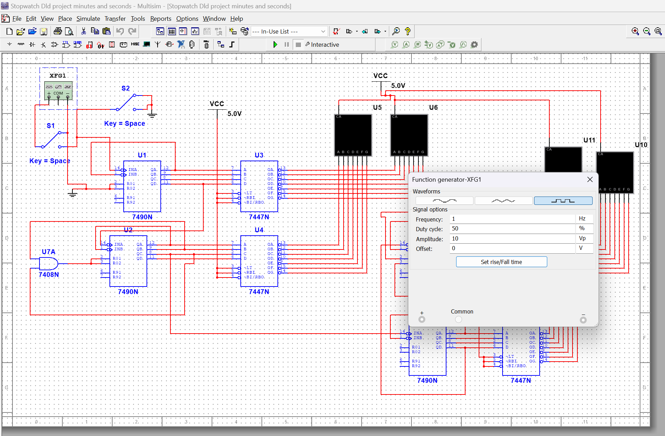
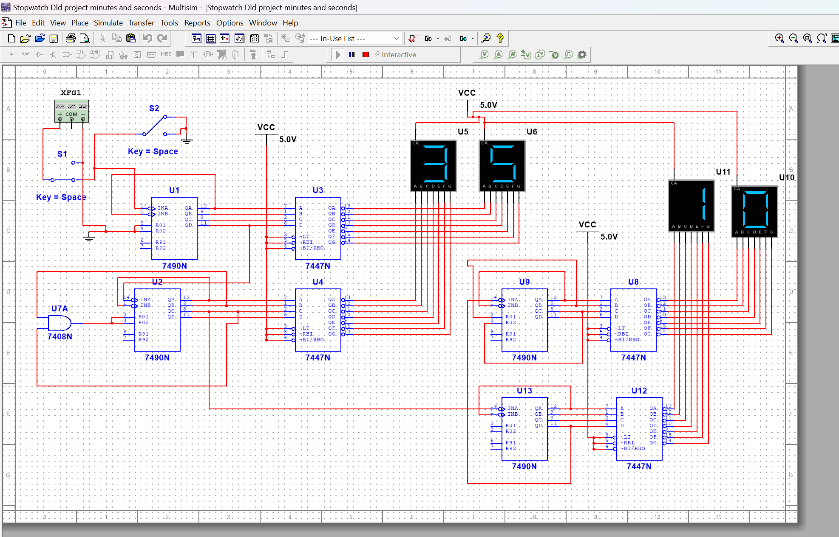
A screenshot of the overall circuit showing components.
A waveform diagram showing clock signal being sent to the counters.
The waveform will show the counting of seconds.
The waveform will show the seconds to the minutes counters.
The numerical output of the 7-segment displays showing the time.
Expected vs. Actual Outcomes: The circuit should work like a stopwatch, counting seconds and minutes. The image shows that it is counting, so the circuit worked as expected with expected output.
Circuit Performance:
Strengths: The circuit has been shown to work as a stopwatch and count and display numerical values. It uses common components to implement a basic digital stopwatch mechanism.
Limitations: The circuit is a basic implementation of a stopwatch using only the necessary components for counting and displaying the time, and has a limited number of functionalities.

- Project documentation
Replicability:

Pin Configurations and Interconnections:
7490N (U1, U2, U9, U13):
Pins 14 and 1 are connected to the clock.
The output pins (QA, QB, QC, QD) connect to the 7447N decoders to send data
Pins 2, 3, 6, 7 are for connecting the counters together.
----------------
7447N (U3, U4, U8, U12):
The input pins connect to the outputs of the counters.
The output pins connect to the seven-segment displays.
----------------
7408N (U7A):
The inputs connect to carry out of the seconds counters.
The output is connected to reset input of minutes counters
----------------
Seven-Segment Displays (U5, U6, U10, U11):
The input pins connect to the output pins of the decoders.

Formulas or Calculations: There are no math formulas in this project but the timer increases by 1 unit for every clock pulse of 1Hz.
Testing and Debugging:
To test, the project circuit was run in the simulator. It was checked that all the parts were connected right. The numbers on the display were checked to make sure they were counting up correctly. The main check was to ensure the wires were connected properly. So, there’s no problem in this stopwatch project

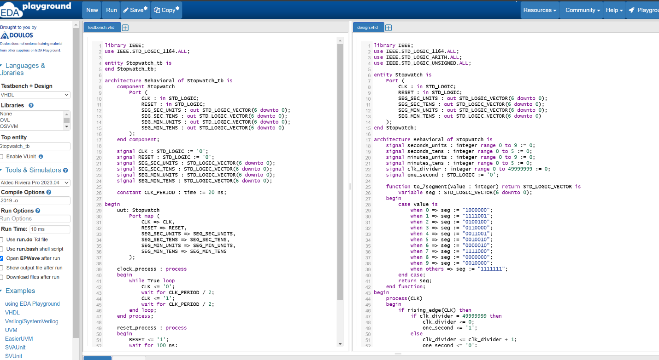
Bonus VHDL Code:
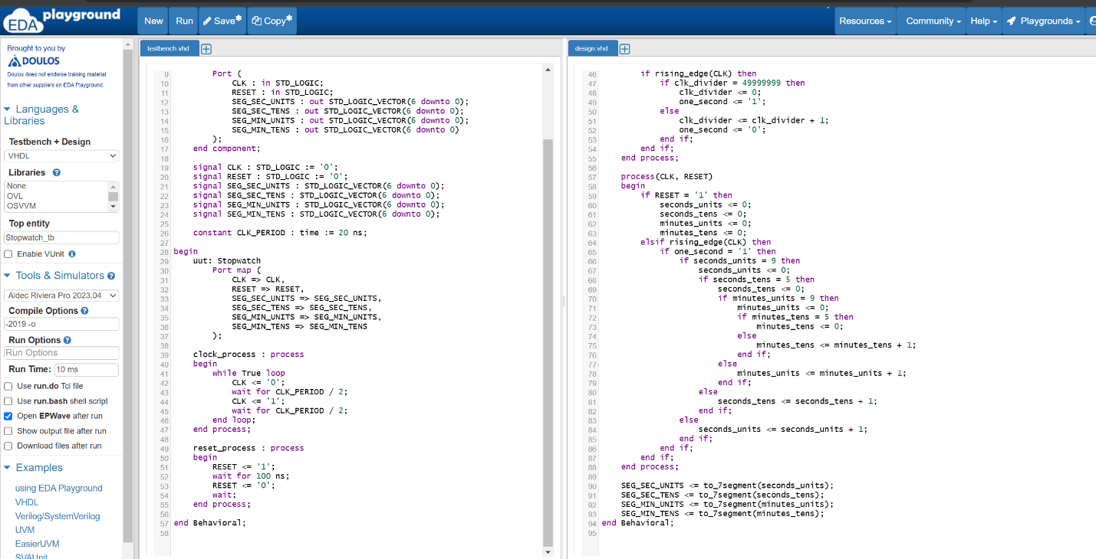

ModelSim Simulation (Visualize timing diagram):
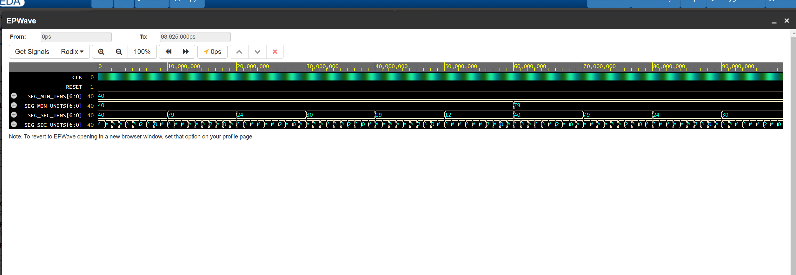
Waveform:

